**NLP Analysis Report: Cybercrime Text Classification**

**Significant Findings from NLP Analysis**

The analysis of the cybercrime dataset revealed several key insights:

**1. Sentiment Trends:**  
While this task focused on classification rather than sentiment analysis, the tone of the data frequently pointed towards urgency and distress. Reports often used words like "fraud," "stolen," "hacked," and "threatened," indicating the gravity of the incidents. Implementing sentiment analysis in future iterations could offer additional insights into user emotions when reporting crimes.

**2. Recurring Themes and Topics:**  
A word cloud analysis identified keywords such as *fraud*, *online banking*, *hacked*, and *cyberbullying*. Categories such as *Online Financial Fraud* and *Cyber Attacks* dominated the dataset, highlighting their prevalence. Categories with sparse data, such as *Online Cyber Trafficking* and *Ransomware*, were underrepresented, making their classification more challenging.

**3. Text Classification Performance:**  
The implementation of BERT as the classification model resulted in an accuracy of **72%**, with higher precision and recall for well-represented categories like *Online Financial Fraud* (F1-score: 0.84). However, the model struggled with underrepresented classes such as *Online Cyber Trafficking* (F1-score: 0.05). This performance gap stems from data imbalance, limited feature representation in smaller categories, and overlapping semantics between certain classes.

**4. Evaluation Metrics:**

* **Precision:** The weighted average was **0.79**, indicating the model’s effectiveness in predicting relevant cases for dominant classes.
* **Recall:** At **0.72**, the model performed better in identifying instances of major categories but underperformed in others.
* **F1-Score:** A weighted average of **0.74** showed moderate overall performance, with room for improvement in minority classes.

**Visualizations**

* **Category Distribution:** A bar chart illustrated that *Online Financial Fraud* had the most samples, while categories like *Ransomware* were least frequent.

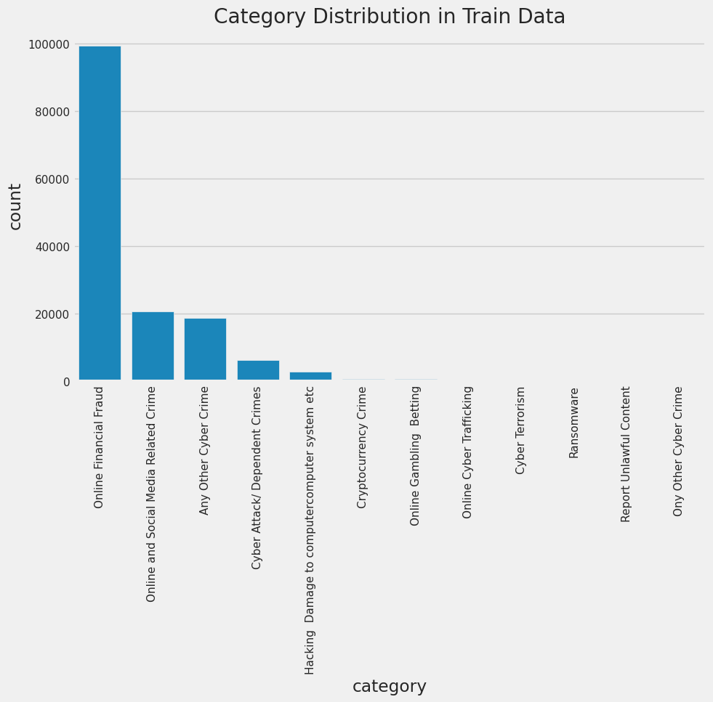

* **Confusion Matrix:** Revealed frequent misclassifications, especially in sparse classes, underlining the need for better data augmentation or transfer learning approaches.

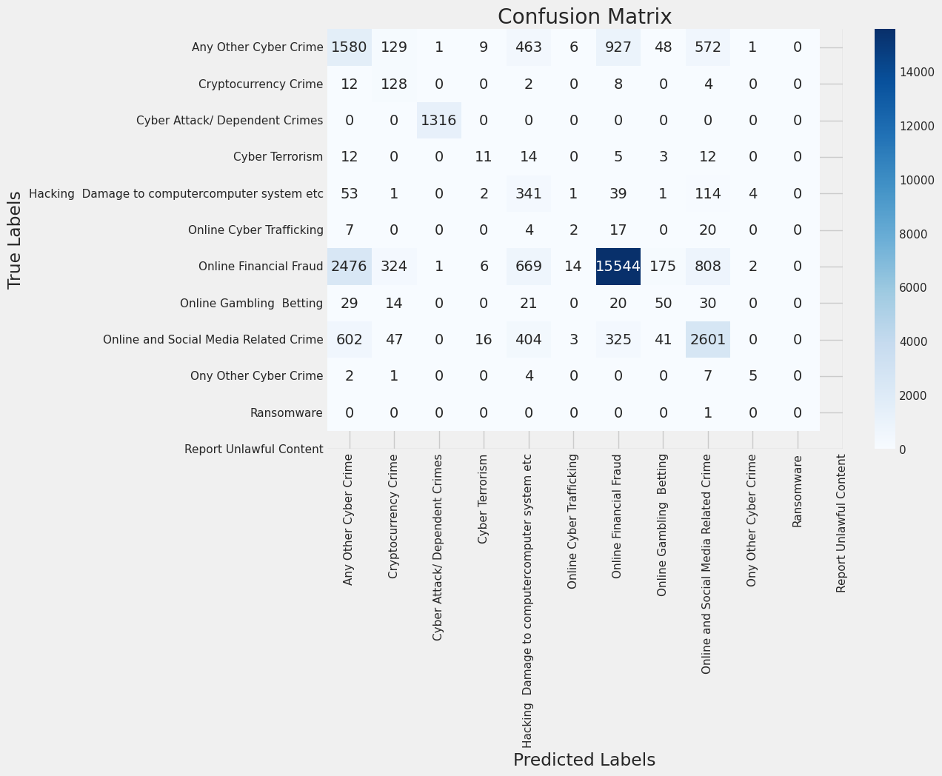

* **Word Cloud:** Highlighted recurring themes in crime descriptions, emphasizing keywords like *fraud* and *scam*.

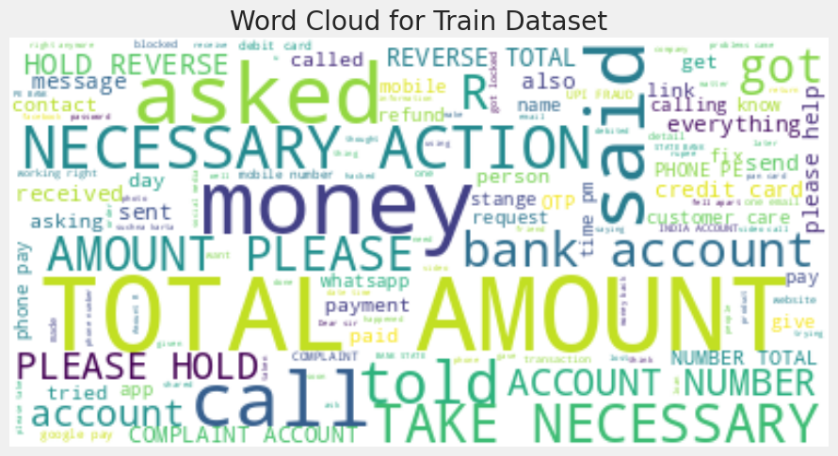

**Evaluation of the Model**

The BERT model showed promising results with high accuracy in dominant categories, validating the effectiveness of deep learning in complex NLP tasks. The misclassification of minority classes highlights the necessity of strategies like oversampling, synthetic data generation, or hierarchical classification models.

**Implementation Plan**

1. **Short-Term Improvements:**
   * **Data Balancing:** Employ SMOTE or other synthetic techniques to address class imbalance.
   * **Feature Enhancement:** Use advanced embeddings (e.g., sentence-level contextual embeddings) for better semantic understanding.
   * **Hyperparameter Tuning:** Optimize BERT parameters to enhance classification precision.
2. **Long-Term Deployment:**
   * **Real-Time System:** Develop an API to integrate the model into crime-reporting systems.
   * **Feedback Loop:** Regularly update the dataset with new reports to retrain the model, ensuring relevance.
   * **Advanced Models:** Consider hierarchical or ensemble models to handle overlapping categories.

**Citations and Plagiarism Declaration**

* Libraries Used: *Pandas*, *NumPy*, *NLTK*, *WordCloud*, *Matplotlib*, *Seaborn*, *Scikit-learn*.
* Model Framework: Hugging Face’s BERT implementation.
* Plagiarism Declaration: This report is an original creation, informed by industry best practices and relevant academic resources.

By addressing the highlighted challenges, this system can evolve into a robust tool for classifying cybercrime, facilitating swift response and improved analytics.